# Part (A)

Inputs:

El = 0 🡪 elevator angle

Th = 0 🡪 motor is turned off for gliding flight

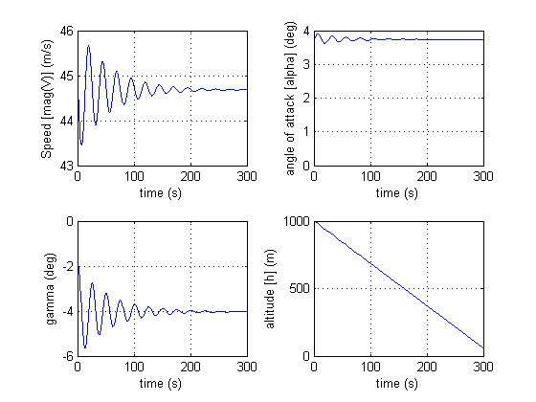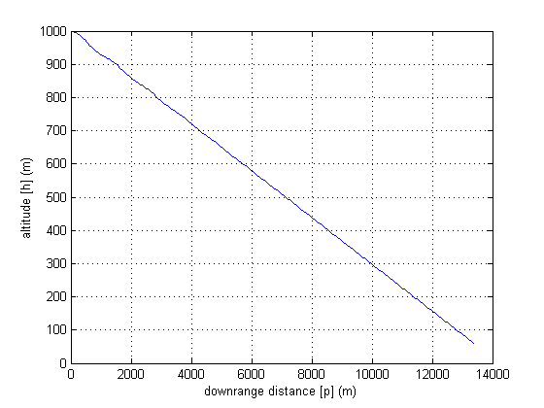

# Part (B)

Inputs:

El = 0.0278 radians = 1.593 degrees 🡪 elevator trim angle for horizontal flight

Th = 100 hp 🡪 motor horsepower

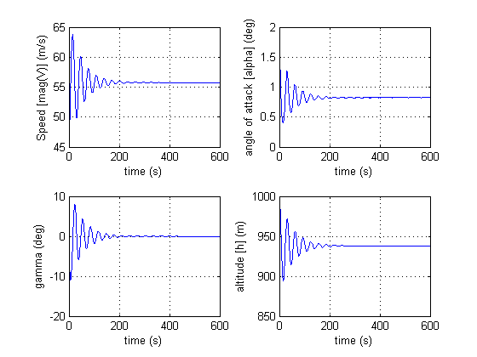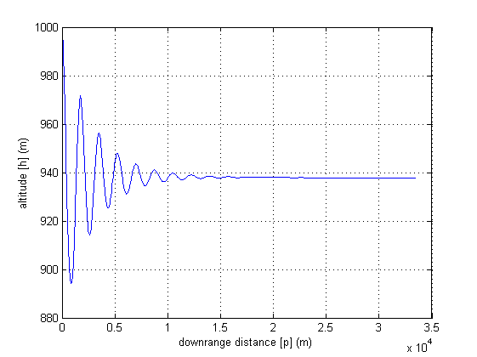

Code:

clc; clear; close all

%aircraft properties

W = 2650*4.44822162; %newtons

g = 9.81; %m/s/s

m = W/g; %kg

S = 174*0.092903; %m^2

c = 4.9*0.3048; %m

J2 = 1346*1.35581795; %kg*m^2

el = 0.0278; %rads

rho = 1.225; %kg/m^3

%lift constants

CL0 = 0.307;

CLalpha = 4.41; %/rad

CLel = 0.43; %/rad

CLalpha_dot = 1.7; %/rad

CLq = 3.9; %/rad

%drag constants

CDM = 0.0223;

k = 0.0554;

CLDM = 0;

%moment constants

CM0_R = 0.04;

CMalpha_R = -0.613; %/rad

CMel_R = -1.122; %/rad

CMalpha_dot_R = -7.27; %/rad

CMq_R = -12.4; %/rad

xcm = 0;

%thrust constants

nu = 0.7; %prop efficiency

th = 100*745.699872; %watts

%th = 0; %hp

e = 0;

eT = 0;

%initial conditions

V0 = 45;

theta0 = 0;

q0 = 0;

alpha0 = 0;

p0 = 0;

h0 = 1000;

sim('cessna_model')

t = simout.Time;

p = simout.Data(:,1);

h = simout.Data(:,2);

V = simout.Data(:,3);

alpha = simout.Data(:,4);

gamma = simout.Data(:,5);

figure(1)

subplot(2,2,1)

plot(t,V)

xlabel('time (s)')

ylabel('Speed [mag(V)] (m/s)')

grid on

subplot(2,2,2)

plot(t,alpha*57.2957795)

xlabel('time (s)')

ylabel('angle of attack [alpha] (deg)')

grid on

subplot(2,2,3)

plot(t,gamma*57.2957795)

xlabel('time (s)')

ylabel('gamma (deg)')

grid on

subplot(2,2,4)

plot(t,h)

xlabel('time (s)')

ylabel('altitude [h] (m)')

grid on

figure(2)

plot(p,h)

xlabel('downrange distance [p] (m)')

ylabel('altitude [h] (m)')

grid on

